<https://docs.spring.io/spring-boot/docs/current/actuator-api/htmlsingle/>

### CURL + Actuator

prérequis: ajoute spring-boot-starter-actuator

**Consulter la liste des caches**

curl http://localhost:8080/bff-investor-app-0.0.1-SNAPSHOT/actuator/caches -i -X GET

**Consulter la cache par son nom**

curl <http://localhost:8080/bff-investor-app-0.0.1-SNAPSHOT/actuator/caches/logos> -i -X GET

http://cacreglux802.sf.ca.lux:8081/ms-investor-resource-app-0.0.1-SNAPSHOT/actuator/caches/traductions

HTTP/1.1 200 OK

Connection: keep-alive

Transfer-Encoding: chunked

Content-Type: application/vnd.spring-boot.actuator.v3+json

Date: Wed, 07 Jun 2023 08:28:00 GMT

{"target":"java.util.concurrent.ConcurrentHashMap","name":"logos","cacheManager":"cacheManager"}

**Clean la cache par son nom**

curl <http://localhost:8080/bff-investor-app-0.0.1-SNAPSHOT/actuator/caches/logos>?cacheManager=cacheManager -i -X DELETE -H 'Content-Type: application/x-www-form-urlencoded'

curl http://cacreglux802.sf.ca.lux:8081/ms-investor-resource-app-0.0.1-SNAPSHOT/actuator/caches/actuator/caches/traductions?cacheManager=cacheManager -i -X DELETE -H 'Content-Type: application/x-www-form-urlencoded'

<http://localhost:8080/bff-investor-app-0.0.1-SNAPSHOT/api/v1/logo/99963514>

# par Jconsole

prérequis: ajouter spring.jmx.enabled= true dans l’application properties

Consulter par Jconsole et clear cache

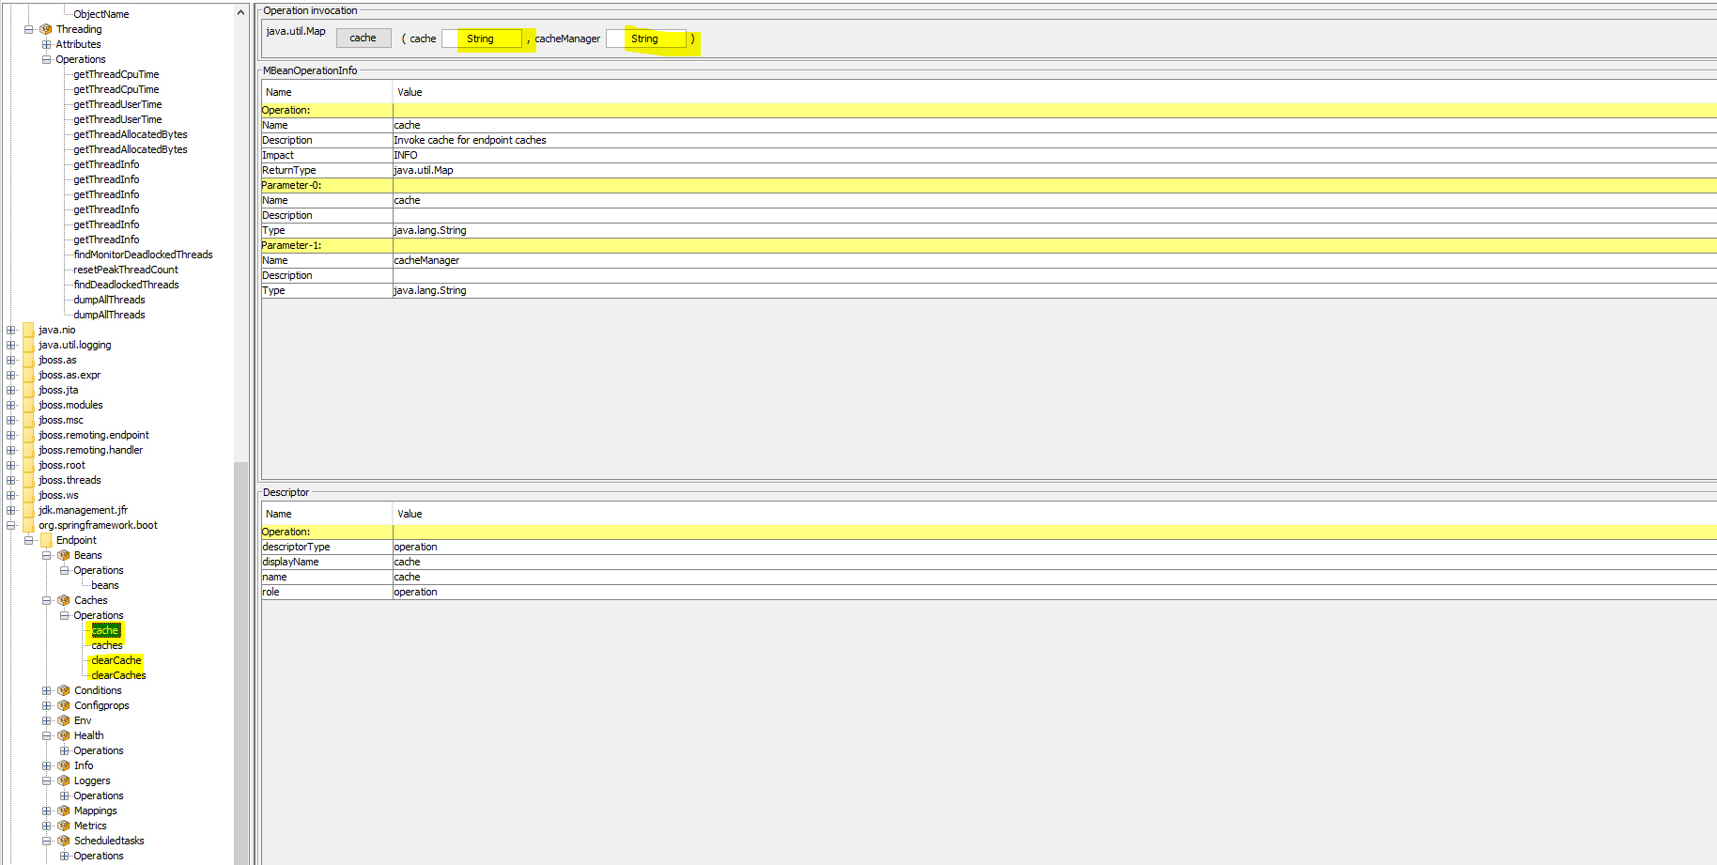

Pour vider manuellement

